We have a user tpl file
Issues> does not run or fails to join or add users in groups:
We need to do manually:
With AWS console remote session, need to add those users and groups manually.
Then need to fix the drives, as they are created with TF but can not be used as it needs to be formatted first

Add-LocalGroupMember -Group “Administrators” -Member “SOG\MAkhtaruzzaman”
Add-LocalGroupMember -Group “Administrators” -Member “SOG\sbollampally”
Add-LocalGroupMember -Group “Administrators” -Member “SOG\troland”

Add-LocalGroupMember -Group “Administrators” -Member “SOG\nSOG-SP_GTA_Portal_ADM-G”
Add-LocalGroupMember -Group “Administrators” -Member “SOG\Everyone”
Add-LocalGroupMember -Group “Administrators” -Member “SOG\svca_gta_spinstall”

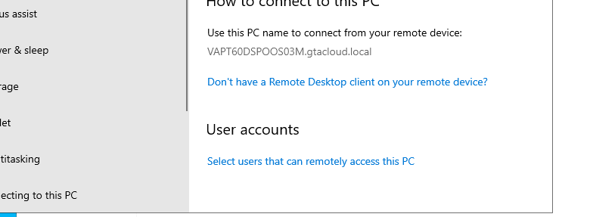

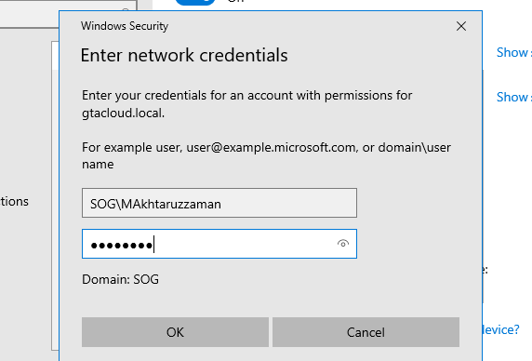

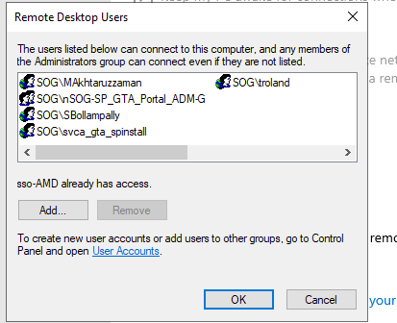

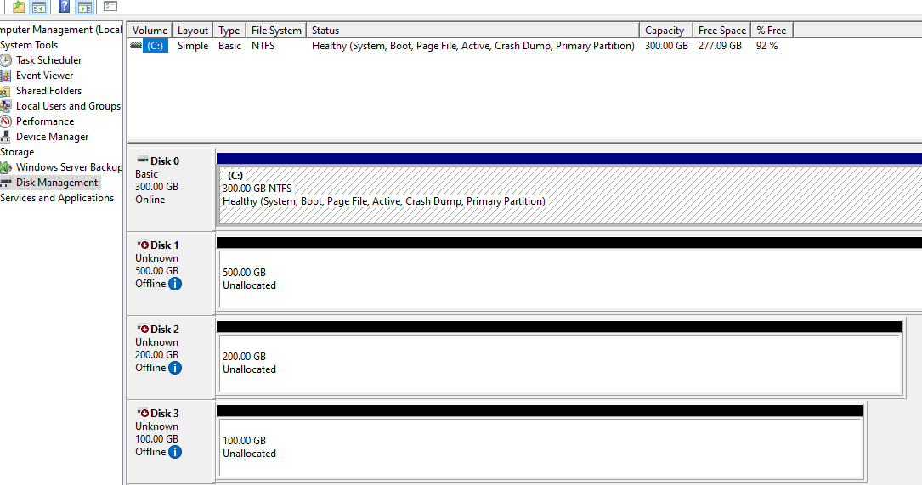

"Time","Message"
"6/23/2025 5:52 PM","Created folder to store log file."
"6/23/2025 5:52 PM","Userdata script is stored at : C:\Windows\system32\config\systemprofile\AppData\Local\Temp\EC2Launch636071851"
"6/23/2025 5:52 PM","The name of the machine is incorrect and needs to change from EC2AMAZ-1D6QC4S to VAPT60DSPOOS03M."
"6/23/2025 5:52 PM","The machine will be renamed and restarted."

